Analyzing Network Delay and Routing Changes Over Time

Computer Networks and Distribution Processes

CIS 427.01

Group 3 - Michelle Sroka, Taylor Williams

University of Michigan-Dearborn

April 11, 2023

## 

## Table Of Contents

Table Of Contents 2

**Network Measurement Report 3**

Abstract 3

Introduction 4

Methodology 5

Results 5

Conclusions 13

What Was Learned 14

References 15

# Network Measurement Report

## Abstract

Our goal is to assess link latency for a five-day period and investigate how the latency and number of hops differ throughout the day and week. To achieve this, our group, Taylor Williams and Michelle Sroka, utilized the Traceroute computer network diagnostic tool to monitor the routing stability of our Internet providers, AT&T and Spectrum, and the Ping utility network testing tool to monitor the loss and delay performance characteristics of our chosen internet path domains.

When tracking the domains of our different chosen target hosts, based throughout the United States, for their changes in network routing behaviors, we experienced minimal differences in which routing paths were conducted and very few losses of packets through the networks used in this experiment. Despite the methodology of collecting measurements from 5 domains per group member and collecting data using both network tools, twice a day for a period of 5 days for each domain, there has been little significant difference in the comparison of either group member’s findings.

## Introduction

With escalating demand for faster and more reliable networks, it has become crucial to understand how network connections are changing over time. Network delays are caused by various factors, including changes in routing protocols, and an increase in the number of devices connected to the network. By using trace routes, users are able to track the path of packets taken from the destination to the host and identify any delays and time-out errors that occur along the way. This is a useful diagnostic tool when attempting to troubleshoot why a certain website is unresponsive.

In theory, network delays should be more common during the day, as a large portion of the population requires using the internet as part of their 9-5 job. With the surplus in active users, there is sure to be an increase in bandwidth required in order to host everyone accessing a website at the same time. This is why even though users input the same domain name, there is a large chance that the domain has multiple IP addresses that it can route to in case one gets too clustered.

Due to this knowledge, our group hypothesized that if network measurements are to be performed during critical high points throughout the daytime when most people are connected to a network (during business hours and early afternoons), we can expect to experience more routing instability of our internet service providers and an uptake in loss and delay performances as compared to performing network measurements during low times in the day, where not many people will be active on a network. We have also theorized that picking destination hosts that provide servers within the United States, are knowingly trustworthy, and are from larger known companies, may also be more likely to provide more routing stability in regards to our internet service providers and better-valued loss and delay performance for our overall network measurement results.

## Methodology

In order to prove our hypothesis, each member selected five different domains, resulting in a total of ten websites to be used as control variables. These websites included Amazon US, Amazon IN, Twitch TV, Spotify US, and Apple US for the first group member, Michelle, and Sephora US, Zumiez, Hertz, TikTok, and Pinterest for the second member, Taylor. With these websites, we tracked the routing paths that were taken twice a day, as well as counted the pings of each site throughout a five-day period. By doing so, we were able to do a proper analysis of these routes and track for any patterns, or lack thereof.

As for Ping, we restricted ourselves to only sending 120 echo requests to stay consistent for each source and automatically terminate after hitting the request number specified. After collecting all possible data, we analyzed the results in Excel, graphing out all our available data in order to spot inconsistencies in the networks we selected.

## Results

For Michelle’s portion of the project, the domains tended to be mapped dynamically through several dispersed servers. So, their IP addresses were used instead of their host names after the initial run-through to prevent inconsistent routing when possible. Michelle tried using three different Amazon domains: Amazon.com, Amazon.in, and Twitch.tv, in order to compare how different branches of the same company manage their available resources. Since Twitch was a recently added domain to the company and is still considered a subsidiary, their results varied more from the Amazon store sites, as they still host on their original servers instead of transitioning to Amazon. Both of Amazon's domains stayed relatively similar, in their results. There were zero to three timeouts occurring depending on the time of day, typically during the Eastern time zone daytime hours, Amazon US would have more time-outs that occurred compared to Amazon IN, which had a higher rate of time-out requests in the EST afternoon. Furthermore, Amazon US had enlarged peaks in ping regardless of time, with the highest reaching 335 milliseconds. Seeing as though this is one of the most trafficked websites in the US, this is not really a surprise. The number of users constantly browsing can congest the servers and lead to increased milliseconds. There was also a slightly higher total average ping in Amazon US, at 34 throughout the five days versus an average of 31.1 at Amazon IN.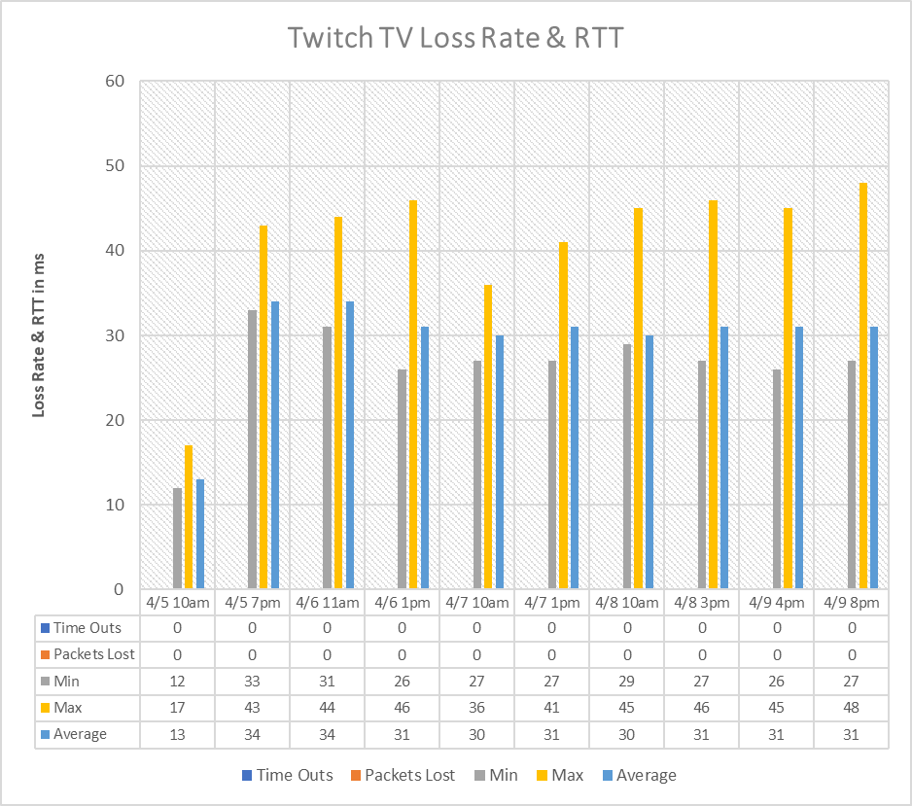

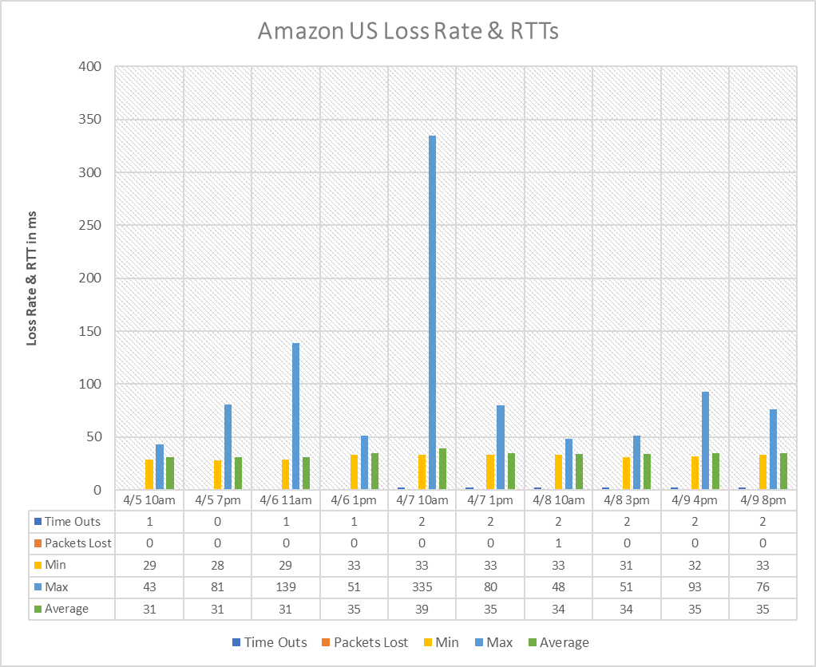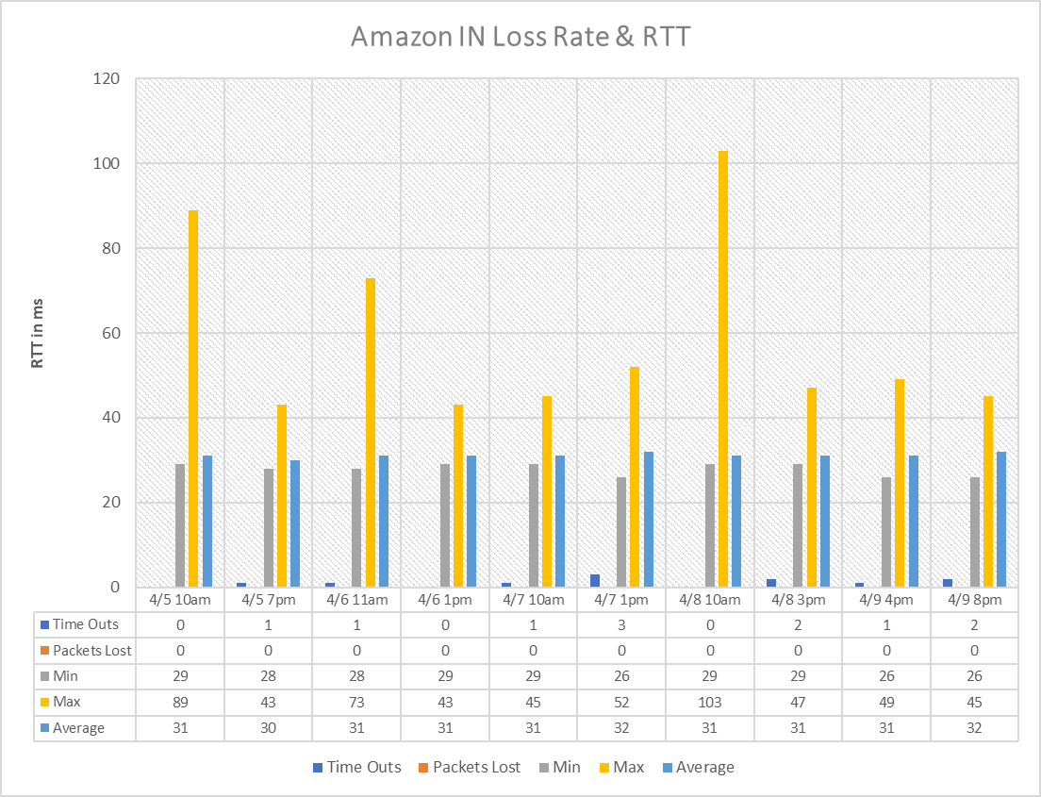

In addition to researching the Amazon domains, I also compared Spotify and Apple Music, as they are both well-known music streaming service providers. The domains had the same dynamic mapping as Amazon, so their IP addresses were used to prevent testing several dispersed servers. When comparing the two sites, Spotify did not have any days without time outs occurring, always having one to three, and mainly during the day between 10 am-3 pm. Apple did not fair much better, as there were only two days without time outs. Both sites were able to transition without any major packet lossage, Spotify only lost one packet total within the five-day period whereas Apple lost none. But, Spotify also had a much lower average millisecond roundtrip time, averaging at 14ms whereas Apple averaged 26. Both websites seemed to reach their maximum ping latency from 11am-1 pm on Thursday.

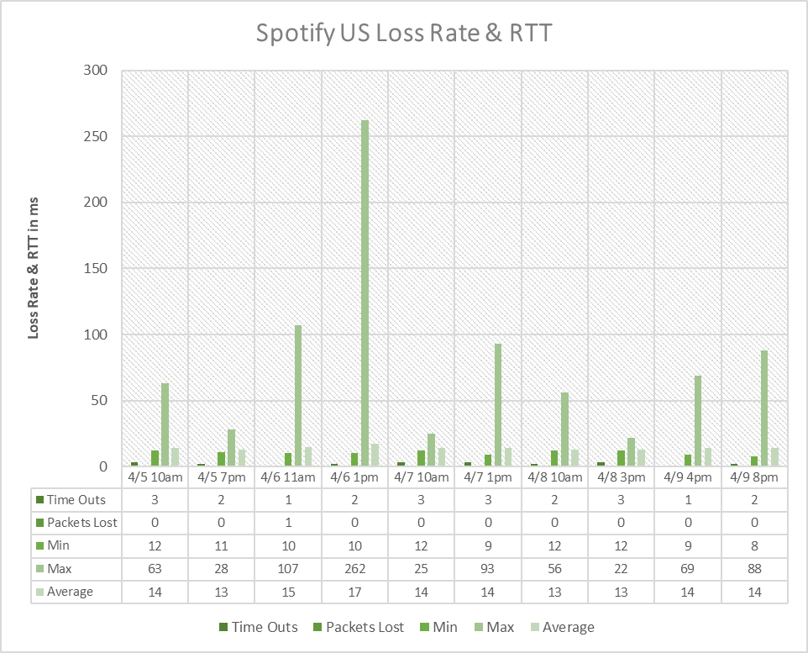

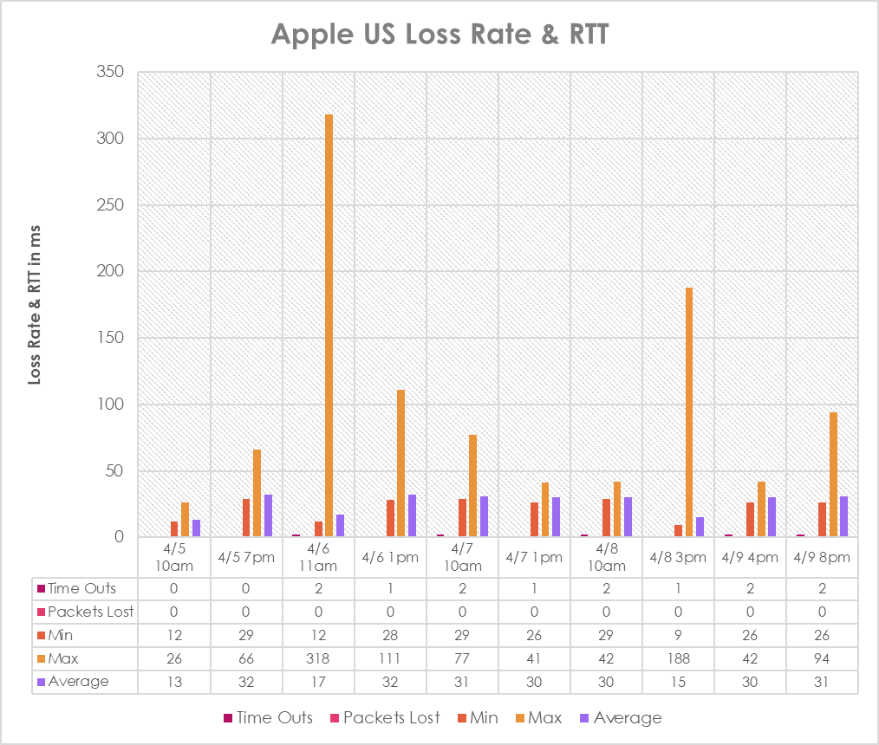

For Taylor’s portion of the project, the chosen destination hosts did not have similar backgrounds as some are retail based, like Sephora, Hertz, and Zumiez, while the others are social media based, like TikTok and Pinterest. It was assumed before performing any measurements, that the retail-based target hosts are more likely than the social media-based hosts to have more properties of protection in place for their clients, which may play a factor in how the paths of the retail hosts will vary in relation to the social media hosts.

Over the course of the five-day tracking period in regards to the Traceroute network measurement routes observed, there were a few differences in how paths were conducted for each host based on different days of the week. For all target hosts, their routes remained fairly stable, however, every measurement taken had the 4th hop request timeout. The hosts that stayed the most stable, with the number of hops and paths taken, were Zumiez and Hertz, with Sephora also being close in consistency besides the hops differing in amount per day. It seems as if there is a difference in how the paths for the retail hosts operated in comparison to the social media hosts, where the retail hosts have slightly higher stability in comparison. The retail hosts did not face as many changes in paths and hops, and besides Sephora's changes in hops, had more consistency throughout the five-day tracking period.

The nature of the routing changes for the social media hosts observed, TikTok and Pinterest, mostly revolved around the number of hops taken, and because of the changes in the number of hops, the paths per hop differed as well, changing per day and not staying as consistent. For TikTok, the hops bounced between 9 and 7 depending on the day of the week, with only little variation in router interfaces for the last couple of hops’ paths. For Pinterest, the hops went from 9 and 8 for the first 4 days, then 13 and 15 hops for the 5th day. The last day experienced an increase in request time outs per hop, besides the consistent 4th hop time out that occurred for all Traceroute measurements. The 5th day’s first measurement had request time outs at hop 4, and hops 10 through 12, with a different path taken at hop 6, and the second measurement had request time outs at hops 4, and 10 through 14, with a completely different path route taken, with different router interfaces, after hop 6. It seems as if only the target host, Pinterest, experienced any significant change in routing stability on its 5th day in comparison to its previous tracking days that were not seen through the other target hosts observed.

In regards to the Ping measurements taken, each target host received a classification based on the measured losses and RTTs observed throughout the five-day period. For Sephora US, the classification received was “loss free” for all five days of measurement, the only slight difference was on day 5, where the second measurement lost one packet. For Zumiez, the classification received was “loss free” for all 5 days, where on day 1 measurement 1 lost one packet, and on day 4 measurement 2 lost one packet. For Hertz, the classification received was “loss free” for all 5 days, where each measurement on day 3 lost only 1 packet, and on day 5 measurement 1 lost 1 packet. For Tiktok the classification received was “loss free” on days 2-5, and “minor losses” on day 1, where measurement 2 lost 2 packets. And lastly, for Pinterest, the classification received was “loss free” for all days except day 4, where the classification was “minor losses”, measurement 1 had 2 packets lost.

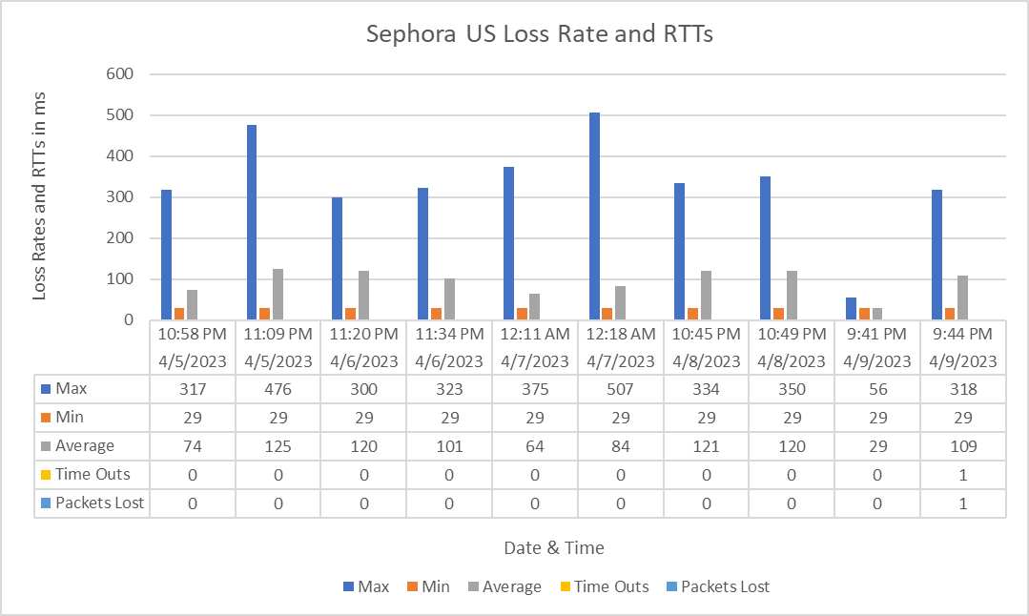

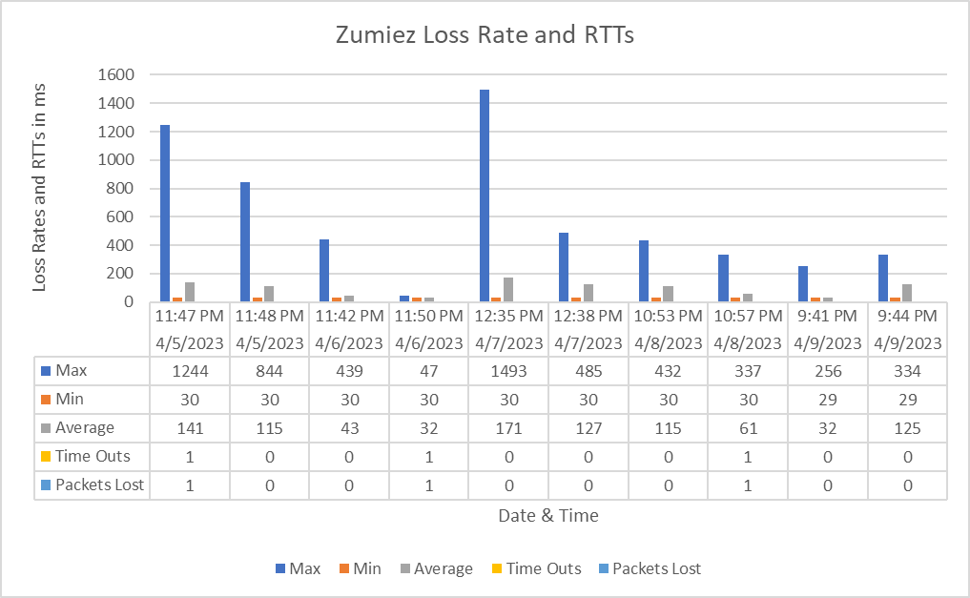

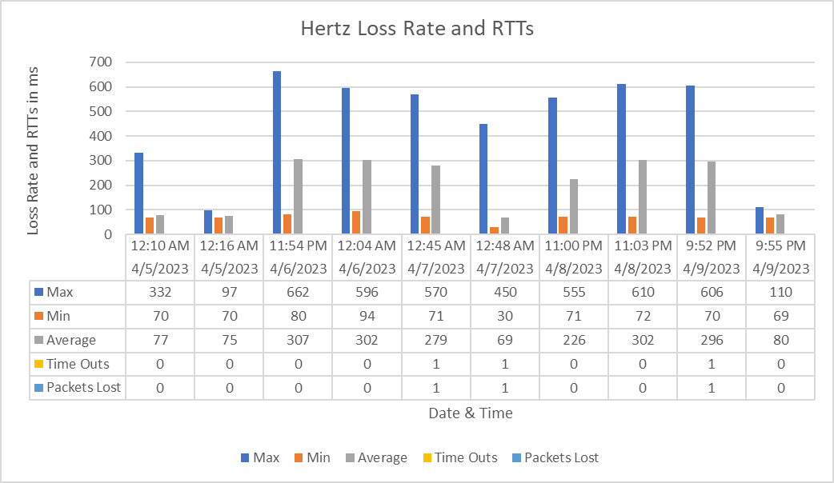

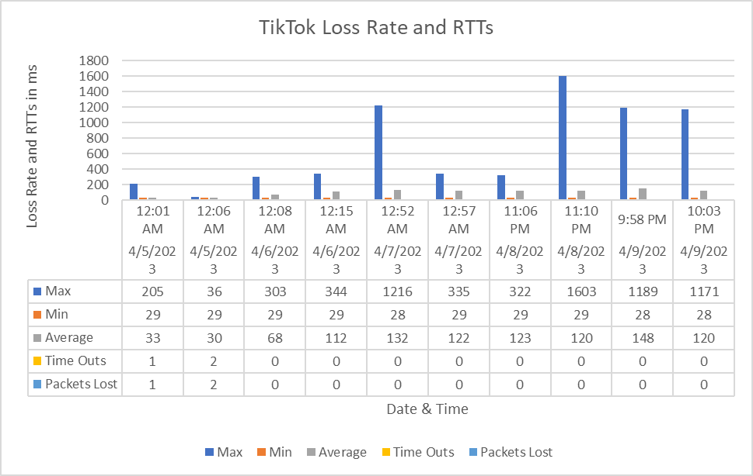

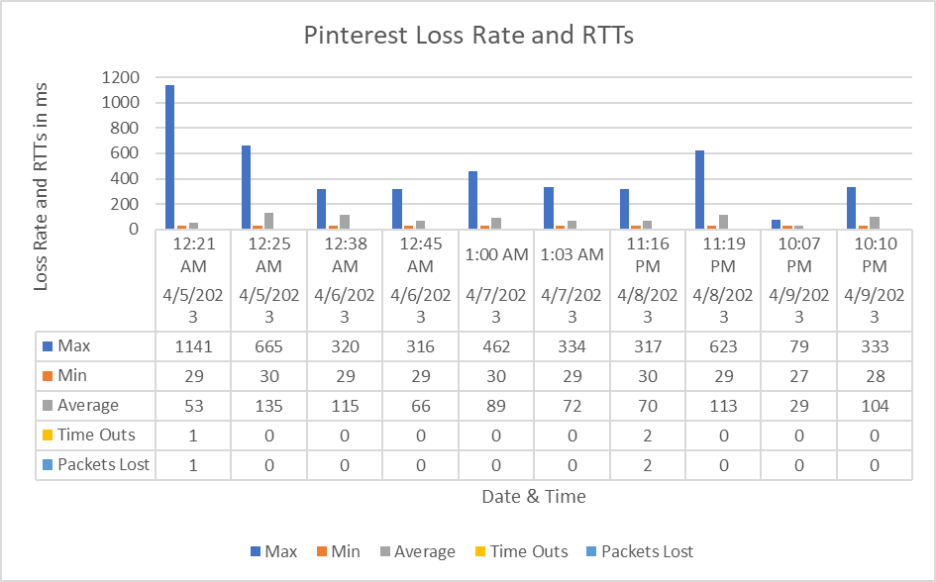

## Conclusions

In conclusion, between both partners, we experienced very little packet loss and minimal rerouting when observing our network measurements for our target hosts. We found that the data routes that were taken by our chosen host domains stayed relatively similar with zero to minimal packet loss occurring. Not once has any host gone over 1% in packet loss rate and the most changes witnessed were the varying number of hops and variations of router interfaces within network packet paths.

Based on our findings, we can conclude that depending on the time of day in which the measurements are taken, there does not seem to be a significant impact on the loss rate and the RTTs of the hosts. Different types of hosts, such as hosts from retail companies or hosts from social media companies, seem to have different systems in place, such as firewalls that result in the same hops timing out, which affected how our network packet paths were structured. Our team has witnessed that retail hosts seemed to provide more routing stability in these instances but overall, the target hosts studied did not experience any major losses or drastic changes in paths throughout the course of our five-day measurement period.

## 

## What Was Learned

Throughout the conduction of this experiment, our team investigated the impact of network delays and delay variations on applications like voice-over IP and time-sensitive financial transactions. From our findings, we have noticed that larger well-known domain hosts are less likely to have routing errors, as they put a lot of effort into making sure their servers are accessible at all times. The same can also be said for hosts that provide secure client transactions, such as retail companies, where there are layers of security involved in their systems that make their networks stable for clients. This also leads to the understanding that time-out errors on the same hops are a sign there is an issue with the routers on the hops or a firewall setting.

If there were some aspects we could go back and redo in this experiment, we would try to be more consistent with the timing of our measurements on each day. Instead, we would’ve made sure to curate more measurements during different times of the day, instead of focusing on a specific time frame. Another aspect worth changing would’ve been taking more than just two measurements for day 5 for the Pinterest host, as that was the one host with the most varied results overall. By taking another couple of measurements on that day, it could be determined whether or not that host was generally a little less stable than the rest or if the varied measurements taken were flaws or not.

## References

Davie, Bruce S., and Larry L. Peterson. Computer Networks: A Systems Approach. Elsevier, 2012.

Computer Networking: A Top-Down Approach Featuring the Internet, Kurose & Rose,

Pearson Addison Wesley.

Kurose J. F. & Ross K. W. (2005). Computer networking : a top-down approach featuring the internet (3rd ed.). Pearson/Addison Wesley.

Tanenbaum A. S. (1996). *Computer networks* (3rd ed.). Prentice Hall PTR.